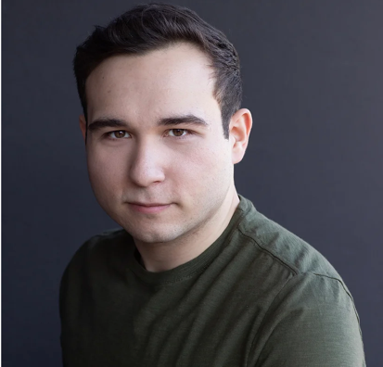
Ryan Negrón
Chicago Representation: vo@stewarttalent.com
+ 312-943-3131
Website: www.ryannegron.com
Email: ranthonynegron@gmail.com

Anime/Animation
Shinobi no Ittoki Himura Takane Crunchyroll/Shawn Gann
I’m the Villainess… Lester Crane Crunchyroll/Jad Saxton
How a Realist Hero… Sur Norn Funimation/Shawn Gann
My Hero Academia Additional Voices Crunchyroll/Morgan Laure
Strike Witches: Road to Berlin Additional Voices Funimation/Tyson Rinehart
Mars Red Additional Voices Funimation/Jad Saxton
Case Study of Vanitas Additional Voices Funimation/ David Wald
Video Games
Kingdom War Aldyrch Fansipan Limited
Elegies: AYA Dr.Louie Laurent Dream Squircle
Moon Observatory Faust Batensan
Not It Vinnie Snowhaven Studios
Eximius Seize the Frontline GSF Engineer Ammobox Studios
Glass Heart Trent Roberts Eternal Love Studios
Education/Audiobooks
Camp Selway Roy/Leo Go Kid Go
R. L. Stine’s Story Club Captain Blackboots/Logan Go Kid Go
Snoop and Sniffy Winnie/Bean Go Kid Go
Gem Sisters Podcast DJ Cake Frosting Go Kid Go
Whale of a Tale Pete The Pufferfish Go Kid Go
After My Last Breath Narrator Pocket FM
Training
Southern Illinois University Carbondale: BA in Theatre
Acting—J. Thomas Kidd, Segun Ojewuyi
Voice Over
Sessions Class—Chris Rager, Tia Ballard, Monica Rial and Tyler Walker
Voice Acting Mastery and private coaching—Crispin Freeman
ADR Master Class—Wendee Lee
Video Game Clinic—Cassandra Lee Morris
Video Game and Animation Audition Class—Joel McDonald
Special Skills
ADR/Dubbing; Improv; Coursework in IPA; RP English, Brooklyn, and Russian dialects; Drunk impediment

